1. Things that you need for a new scene
   1. Rail
   2. Jukebox
   3. Devcheats
   4. LevelControl
   5. Player
   6. PlayButton

1. Create an event system by right clicking in hierarchy>create>UI>eventsystem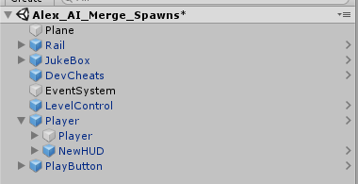

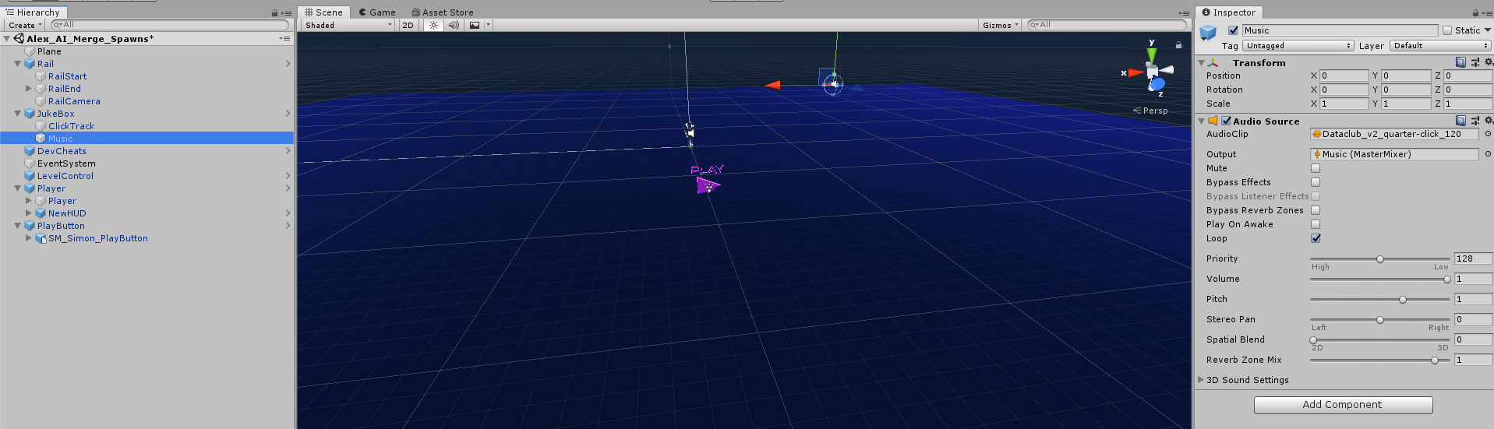

1. To set the music to a specific track, change the audio clip in the music gameobject. If it’s a different song, you will need to do the same thing to the clickTrack gameobject’s audioclip
2. Below is what a spawner looks like, they are defaulted to a preset Spawner. Uncheck for it to be randomised
3. Variables
   1. Spawn Type: is a selectable list where you can choose the enemy you want to spawn
   2. Enemy Max: Maximum enemies that can be spawned from this spawner at one time.
   3. Spawn Frequency: the time it takes for an enemy to spawn.
   4. Spawner HP: dude come on…
   5. AI Spawned: number of AI it has currently spawned.
   6. Spawn Radius: The radius in which the AI can be spawned.
   7. Default Spawn: Where it will spawn if it can’t find a place to spawn.
4. Buttons
   1. First click FindLevelManager (you need to have it for reference)
   2. Spawn Enemy:… spawns enemies.
   3. SetMeshColor: changes the spawner to the color of the enemy spawned.
   4. TestDamage:... Tests damage is working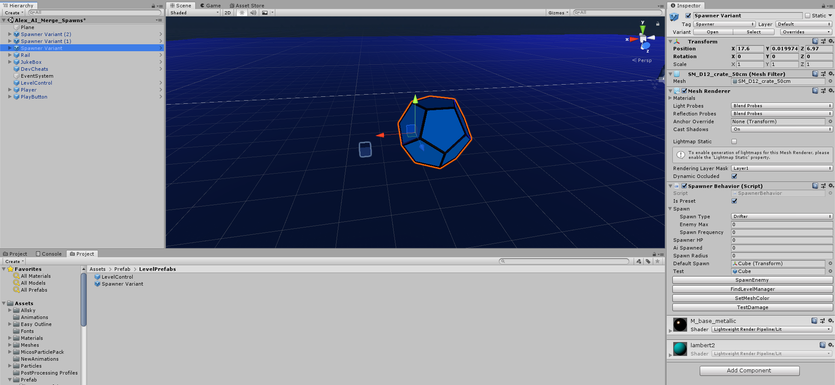

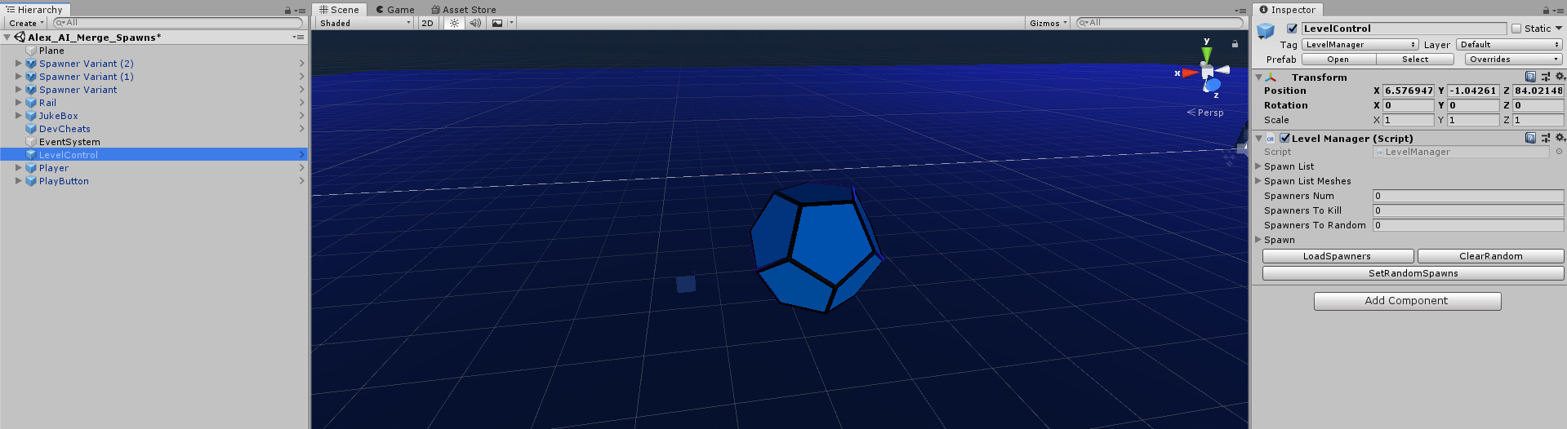

1. Setting Up the Level - See Above ^
   1. You dont need spawn list or spawn list meshes, they are reference to the enemy and color of mesh for the spawner
   2. Click LoadSpawners to get the number of spawns in scene. It will get how many spawners you have not set to a preset.
   3. Spawn is a list of spawner random spawner sets that you have, make it equal to the random spawns you have.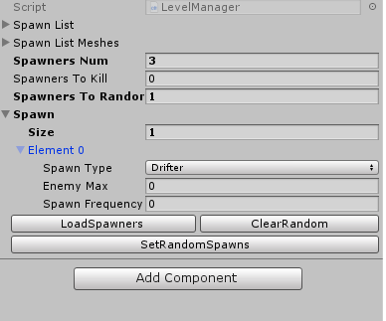
   4. So if you have 1 random spawn set the size to 1 and make a desired spawner with type, maximum, and frequency of spawned enemies.
   5. SetRandomSpawns will set all of the random spawns to the list which you have set.
   6. Clear Random will clear the list of random spawners (if you have decided to make more or less of the spawners preset).
2. Setup the Navmesh
   1. Open the navigation tab in Unity, it will appear in the top right corner normally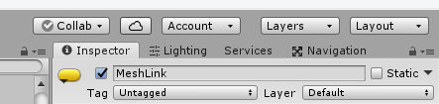
      1. If it’s not there you can find it under Window>AI>Navigation
   2. Open the Bake tab and press the bake button at the bottom, this will make the default navmesh
   3. In order to adjust if various objects can be walked on or should be avoided
      1. Go to the object tab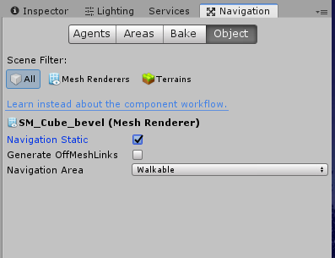
      2. Check Navigation static
      3. Set the navigation area to be walkable or not
   4. Once everything has been added correctly, click the bake button you pressed at the beginning
3. Adding jump nodes
   1. Jump nodes are important for making enemies go over specific objects or climb down from areas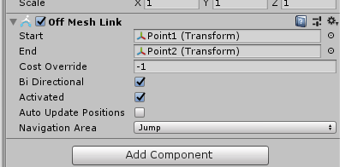
   2. A prefab of the jump node is in the prefabs folder under the name “JumpNode”
   3. Drag this in and put the two childed gameobjects where you want the AI to jump to and from
   4. If you want them to be able to go back and forth from these nodes or just one way, you can change it through the main gamobject’s component
   5. If a mesh link isn’t bi directional, you may place the nodes backwards, if this happens you can just switch the gameobjects in the start and end areas
   6. I haven’t tested these a lot, so I it’s always better to go overboard with these - Simon